One serious problem that the world is facing is food security
That is why I am majoring in agriculture, I would like to help achieving this world wide problem by mainly giving awareness
Food Security
Definition: “Food security exists when all people, at all times, have physical, social and economic access to sufficient, safe, and nutritious food to meet their dietary needs and food preferences for an active and healthy life.” – World Food Summit, 2009
Explanation: Availability: -Agricultural Production/ Agricultural Import
Access: Resources or Entitlement (arrangement that enable people to produce or purchase food
Stability: Emergency food aid, Social Safety Nets (response to shcks)
Utilization: Non Food Inputs sanitation and clean water
Nutrition Knowledge and Practices: select adequate diets

Measure Food Security :
Hunger … cause of global hunger:
Food wastage is high:
In the United Kingdom, “a shocking 30-40% of all food is never eaten;”
In the last decade the amount of food British people threw into the bin went up by 15%;
Overall, approximately $38 billion US dollars worth of food is thrown away, every year.
In the US 40-50% of all food ready for harvest never gets eaten
The impacts of this waste is not just financial. Environmentally this leads to:
Wasteful use of chemicals such as fertilizers and pesticides;
More fuel used for transportation
More rotting food, creating more methane — one of the most harmful greenhouse gases that contributes to climate change.
The direct medical cost of hunger and malnutrition is estimated at $30 billion each year.
Diversion of land use to non-productive use
Increasing emphasis on export-oriented agriculture
Inefficient agricultural practices
Natural Causes as Famine
Drought
Over-fishing
Poor crop yield
Armed Conflict: Hunger is often used as a weapon oil embargo 1973
Food shortages and famine are used to starve enemies into submission
Farming is reduced because of direct attacks
In addition, land-mining and well-poisoning make food and water inedible
Malnutrition(BMI):
Many forms stunting (people are too short for their age)
Wasting (people are too thin for their height)
Obesity (people are overweight)
57/129 surveyed countries currently experience undernutrition and overweight (obesity)

History: the MDG or Millennium Development Goals
The UN’s Millennium Development Goals seek to reduce the percentage of hungry people by half by the year 2015
In 2002 the U.S. spends $379 billion on military spending
In the same year the U.S. spends a mere $1 billion on global hunger
Millennium Development Goal #1: Eradicate Extreme Poverty & Hunger
– Target 1.C: Between 1990 and 2015, halve the proportion of people who suffer from hunger.

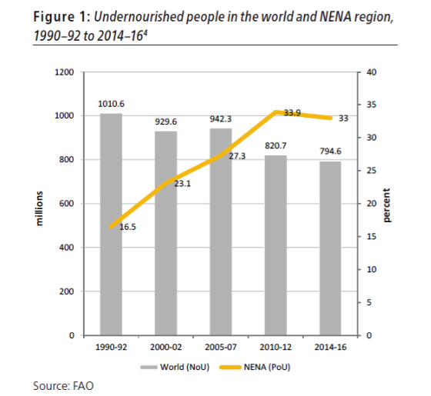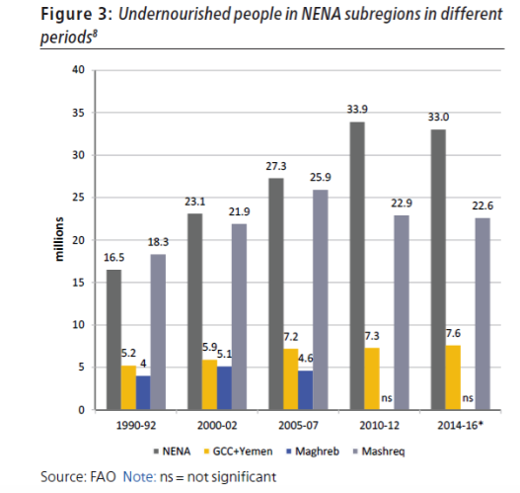

Sustainable Development Goals 2015-2030
Sustainable Development Goal 2:
End hunger, achieve food security and improved nutrition and promote sustainable agriculture.

Problems facing Food Security:
Population growth
Evolving Food Preferences
We will need 60% More Food by 2050
  - Cereals production must increase by 940 million tons to reach 3 billion tons.
  - Meat production must increase by 196 million tons to reach 455 million tons.
  - Oil crops must increase by 133 million tons to reach 282 million tons.
  - Total global demand for crop calories will double as living standards improve.
How will we be able to feed a population of 9.5 billion people by 2050? How will we make agricultural production sufficient to meet nutrition requirements by 2050
Support increased funding of global-assistance programs. The United States uses only a tiny fraction of its money (less than one-half of one percent of the gross domestic product) for overseas food assistance. The nation could easily double or triple this figure without suffering economic harm.
Understand the impact that meat consumption has on the world food supply. Meat production is a biologically inefficient process; the amount of meat produced is infinitely smaller than the amount of feed grain the animals consume. Eating meat elevates consumption of scarce resources and increases pressure on the world food supply. The majority of meat is consumed by developed nations.
Shah, Anup. "Causes Of Hunger Are Related To Poverty." 06 July 2008. 28 Feb. 2009 <http://www.globalissues.org/article/7/causes-of-hunger-are-related-to-poverty>.
Lappe, Frances. "World Hunger." 1998. 28 Feb. 2009 <http://www.worldhunger.org/articles/books/lappe.htm>.

